Luke Hammond | 21013675
Word Count – 2990
Leveraging Nostalgia to increase franchise loyalty: Using a case study of the Video Game Industry in the Context of Pokémon
UMKDWC-60-M – Research Project Module: pg marketing programmes

Table of Contents
Introduction 2
Research Objectives 2
Critical Reflection of Methodology 2
Key Findings & Data Analysis 3
Discussions 4
Recommendations 6
Conclusions 7
References 7
Appendix 8

Introduction
The research topic discusses personal nostalgia – longing for the past, one experienced – and historical nostalgia - one not personally experienced (Stern, 1992) and its ability to create and affect self-continuity which could potentially increase franchise loyalty for consumers. Franchise loyalty will be measured through perceived trust and love for a franchise to connect self-continuity to franchise loyalty (Bae and Kim, 2023). The context of this study is the video game industry, utilising Pokémon as a case study.
There is a lot of support for research into understanding how different media forms affect nostalgia (Reisenwitz, Iyer & Cutler, 2004) or how historical nostalgia in advertisement can produce increased purchase intent (Muehling, Sprott & Sultan, 2014). However, due to the gap in research of video advertisement in creating nostalgia, this project will aid in providing insight into the performance of video as a media form.
Once data collection was completed and anonymised, participants were given a chance to withdraw their data as outlined on the ethic forms.

Research Objectives
- Investigate whether nostalgia is successful in creating self-continuity.
- Explore which branch of nostalgia is more successful in creating self-continuity.
- Explore whether an increase in self-continuity translates into an increase in franchise loyalty.
- Explore whether nostalgia has a place in video game marketing.
- Investigate whether video games can generate nostalgia and self-continuity with audiences.
- Investigate the extent at which video is beneficial as a media form for generating nostalgia.

Critical Reflection of Methodology
The project utilised qualitative research due its ability to capture the richness of social phenomena involving human experiences and perspectives (Lim, 2025). Allowing data to reflect nostalgic memories, creating more in-depth and personal answers for analysis that was contextually relevant to the project.
A limitation of this project was the convenience sample which could generate biased answers that participants thought would benefit the project, it was therefore difficult to create data that reflected the wider population; a shortcoming of qualitative research and its limited generalisability (Lim, 2025). Although, the project takes on the concept of triangulation (Denzin, 2009) which involved interviewing participants of varied populations. Therefore, the data reflects a spectrum of people, allowing for a more credible representation of a broader population.
The analysis conducted for this project was developed through Stirling’s interpretation of thematic analysis and curated through Nvivo assistance. Initial coding dissected texts into meaningful segments, although coding has faced scrutiny for its effectiveness in data reduction (Stirling, 2001), a coding framework was curated revolved around the research objectives to extract the richest data. This proved beneficial for the successive stages of thematic analysis as data was reduced by significant portions with the intention of identifying themes. Allowing for a flexible and structured approach to handling data, that can create a coherent final analysis (King, 2004).
However, interpretations of data are subjective and can lead to bias within data analysis (Nowel et al, 2017) which can lead to data that lacks credibility. Thematic analysis becomes more credible when following a guided approach such as Stirling’s. Proving beneficial to those early in their research career (Braun & Clarke, 2008) and is therefore a perfect fit for this project.

Key Findings & Data Analysis
  - Change: A catalyst for Nostalgia
Participants believed physical marketing is irrelevant to modern day marketing as they are outdated; despite outdated products triggering nostalgia (Appendix TA, Figure 3). There is a place for such material in the context of video games, especially seeing these products adapt and grow as expressed by Participant 9 and 6 (Appendix Q.P9.1). The key takeaway from this global theme is the evolution of gaming and products can be used as a catalyst for nostalgia which can generate self-continuity. Participant 3 reflects on their life growing up simultaneously with the evolution of games and their “urge to play new games” (Appendix Q.P3.4). However, advertisement should focus predominantly on the digital side as physical marketing is considered outdated in the modern world.
  - Personal narratives create self-continuity
Throughout the interviews a frequent receptor for self-continuity was the link to personal nostalgia initiated by childhood memories (Appendix TA, Figure 5). Happiness typically served as a strong connection to the source of those memories (Appendix Q.P2.1), with Participant 1 referring to Pokémon as “a staple … of their childhood”. Consequently, this connection was the only link between Pokémon and the participant to which they would consider themselves loyal to the brand as other times they were quick to dismiss Pokémon (Appendix Q.P1.2). For many the evolution of Pokémon has left them feeling isolated and no longer reflect their recollection of Pokémon (Appendix TA, Figure 5).
However, participants who didn’t play the games, but recognised characters were intrigued by the adverts and could generate historical nostalgia and in some cases personal nostalgia. Participant 7 felt connection to the franchise while being a newcomer to the game due to their ability to recognise Pokémon in the franchise (Appendix Q.P7.1). Thus, while some may feel isolated, there may be others like Participant 7 who are becoming more connected.
  - Socialising fosters Nostalgia and Connection
While historical and personal nostalgia were the focus, it became apparent that multiple moments of nostalgia were linked towards what participants had experienced with others. Nostalgia can be drawn upon a memory of others and shown through the data this ability to interact with others creates connection; and more critically loyalty (Appendix TA, Figure 4). Appendix Q.P4.3 & Q.P4.4 shows while a personal nostalgia was present, the social aspect of the franchise was a big feature of the franchise’s success.
Participants who didn’t share these experiences exhibited a fear of missing out (FOMO) from not having the memories others perceive as a major part of their childhood. Appendix Q.P9.2 was an insight into Participant 9’s thoughts and their desire to experience what others experienced when older iterations of Pokémon were being released. Additionally, Participant 7 while not necessarily experiencing FOMO wishes to share in the memories of their boyfriend who played the games in their childhood, further linking to the social aspect of connection (Appendix Q.P7.2).
Although for many participants, the connection to Pokémon is what they hold dear, and this can be seen in their keenness to keep a “pulse of what's going on” with the franchise (Appendix Q.P1.4).
  - Video as a high-impact medium
The extent to which video was successful as a tool for nostalgia and interest exceeded any set of expectations with many participants dismissing physical marketing (Appendix TA, Figure 6). One significant factor behind this was the creativity video was able to portray in the form of unique art styles. For participant 5, the ability to see 3D sprites of Pokémon and rendered cities stood out above all as it was “fun” and refreshing, reinforcing the point of game evolution generating connection.
Nevertheless, two elements stood above all else: audio and gameplay. Audio could elevate the media form, an element exclusive to digital marketing. Videos use of audio often gave the piece a grander appearance (Appendix Q.P6.3). As for gameplay, in video game marketing it was the deciding factor for whether participants would put their whole trust into the game and franchise, this has become more significant with falling reviews. Participant 5 reserves their judgement and ability to trust until they see gameplay that is not “janky” (Appendix Q.P5.2), a similar mindset was shown from Participant 7 who noticed the lack of gameplay in trailers (Appendix Q.P7.3). However, for others their connection with past games prevailed over the falling reviews and lack of gameplay (Appendix Q.P8.1).

Discussions
  - Literature
The initial framework was developed through three core literature pieces which the project has created new insights. Regarding nostalgia, the established historical and personal nostalgia (Stern, 1992) were the two nostalgia types induced, one of the main triggers being memories connected to others reinforcing Sedikides, Wildschut & Routledge’s (2008) idea of nostalgia triggers. An example of this can be seen in Appendix Q.P3.1 and Q.P6.1 as two differing participants recount their connection is strongly dependent on others. These nostalgic connections create a strong sense of self-continuity, connecting people to a past version of themselves (Ju et al, 2016),
Unlike the stated literature, present-focussed advertisements could generate historical nostalgia that resulted in self-continuity, although not to the degree as personal nostalgia. This can be seen as Participant 1 discusses connecting to their past does not necessarily connect to a past version of themselves (Appendix Q.P1.1) but nevertheless connects to the franchise, “just sort of tugs on the heartstrings of me when I was younger.” However, those who connected to a past version of themselves were more interested and trusting about trying a new game (Appendix Q.P3.2), reinforcing the idea of increased self-continuity creating a stronger purchase intent or in this case franchise loyalty, however this would require further research to confirm.
There were several participants who showed a lack of trust towards Pokémon due to poor recent experiences. Participant 4 acknowledged the lack in quality with the new games has made them apprehensive towards the new games but is willing to try it due to their previous personal connection (Appendix Q.P4.1 & Q.P4.2). Similarly, Participant 3 shows willingness to play the new game having lost a sense of trust in the experience (Appendix Q.P3.3). This contrasts with the claims by Bae and Kim (2023) who believe franchise loyalty heavily hinders on the trust built from experience to create loyalty.
  - Research Objectives
The project was successful in creating nostalgic experiences for participants, influenced by the video portrayal of Pokémon. Appendix TA, Figure 6 illustrates video has the benefit of audio and for many participants music was a trigger for nostalgia, but the addition of voice was the most successful in generating a connection as seen with Participant 5 & 6 (Appendix Q.P5.3 & Q.P6.4). Often the nostalgia triggered for participants was personal (Appendix TA, Figure 5) and were related to childhood experiences of the games. The timeframe of the memories appeared to play a part in the final connection and self-continuity experienced by a participant. A participant who expressed a memory early in their childhood would exhibit more connection to the franchise in comparison to those who encountered Pokémon later in life. This reflects the findings of Muehling, Sprott and Sultan (2014) who observed nostalgia-themed advertisements would yield more favourable brand attitudes to consumers who had prior in-home exposure or personal attachment to a brand.
For participants such as participant 7, the nostalgia induced was historical connecting them to a time on the device Pokémon used to run on (Appendix Q.P7.4) which connected them to a memory with their family. This was a similar occurrence for a few participants and is reminiscent of Reisenwitz, Iyer and Cutler (2004) idea of nostalgia rejuvenating previous products. These nostalgic memories created a connection to the brand of Nintendo in comparison to the franchise of Pokémon.
Overall, if a participant induced personal nostalgia their level of self-continuity was significantly higher than someone who experienced historical nostalgia. However, video was capable of exhibiting both nostalgia triggers and at a significantly high rate. Generally, all participants favoured for a digital media form of advertisement over more traditional physical marketing (Appendix TA, Figure 6).
Video as a marketing tool is of notable cause to be included in video game marketing as it can bridge the gap between “present-focussed”, capable of creating nostalgia for most who view which generated a connection with participants. Although Mathews and Wearn (2016) state Word of Mouth (WOM) from friends is the most effective marketing tool, which was an aspect highlighted in Appendix TA, Figure 4 demonstrating the significance of social aspects in marketing; this WOM can create a sense of connection with friends which is a trigger for nostalgia. In the case of nostalgia in video game marketing it has its place in generating memories and experiences that connect viewers to a franchise from a personal or historical perspective, typically leading to a positive view on a game, even one that is currently viewed with scepticism (Appendix Q.P1.3).
Ultimately, nostalgia works as an inducer of self-continuity, however, it is difficult to state whether self-continuity alone can create franchise loyalty. Self-continuity plays a significant part in audiences displaying loyalty alongside elements such as love (Bae and Kim, 2023). Nevertheless, there remains a gap in research as to the remaining elements that create franchise loyalty.

Recommendations
  - Further Research
Limitations for this methodology can be addressed from an approach that incorporates a sample size that reflects a broader population, accomplished from following the conceptual outline of triangulation (Denzin, 2009). Combined with ensuring all interviews are conducted in-person, as more emphasis on body language can be captured.
While the project addresses gaps within literature and reinforces others, it still leaves a few areas to be answered. One such area are the elements that bridge self-continuity to franchise loyalty, while it is shown that “love” is a significant aspect, there are other reasonings that could be explored to assess the bridge. To successfully fulfil this, a project that utilises a larger sample size enabling generalisability (Lim, 2025) would provide more data for researchers to code and filter through, enabling the identification of new or reoccurring themes.
Additional research could explore the extent to which video as a media form could be compared to more traditional marketing tools such as poster. While the research can successfully identify video as beneficial, it is limited to the extent of it due to it not being able assess against other mediums. Reisenwitz, Iyer, and Cutler (2004) were successful in identifying physical advertisement as inducing nostalgia, both data sets have varied focuses and is therefore difficult to draw comparisons from. Thus, any future methodology should include the two mediums to draw final conclusions with varied media franchises.
Finally, qualitative data can be considered subjective and perhaps unreliable depending on how the methodology was carried out (Lim, 2025). To draw more conclusive results for the success of nostalgia as a viable marketing tool a quantitative approach could be conducted which will generate data that can assessed via the two-tail test.
  - Practice
The project created key insights in video game marketing, the most significant being the success of nostalgia as a successful tool for connecting to audiences. Although further research may be needed to indicate how successful an advert is at inducing personal nostalgia, due that branch having the highest rate of self-continuity (Appendix TA, Figure 5). However, this research is mostly compatible with well-established franchises as their longevity enables the possibility to connect with audiences’ childhood memories which exhibited the best results for self-continuity and loyalty. Additionally, this nostalgia element appeared to reduce the need for trust between user and franchise. Although, in some cases trust was needed (Bae and Kim, 2023) which can be established through the showcase of gameplay in video (Appendix TA, Figure 6).
Based on the projects findings, video is a medium the industry should put focus on. It can create a source of nostalgia as well as build confidence in audiences through gameplay (Appendix TA, Figure 6). The use of music in video appeared to elevate the contents, creating a more interesting experience for participants. Additionally, the incorporation of human voice appeared to increase connection with advertisements, perhaps due to the social aspect; (Appendix TA, Figure 4) engagement with others creates a stronger connection and is a trigger for nostalgia (Sedikides, Wildschut & Routledge, 2008) which establishes self-continuity. While previous research has shown celebrity endorsements to be successful at increasing brand reputation and connection with audiences (Yao, Liu & Guo, 2025), there is a gap in literature for the inclusion of the everyday person, especially within the gaming market. Therefore, further research would establish the level of connection the inclusion of people and voice creates regarding video games.
Lastly, participants appeared to respond well to change if it improved on the past (Appendix TA, Figure 3). When left stagnant audiences increased apprehension and scepticism towards a product, viewing them as more of a “cash grab” (Participant 9), thus change needs to add something to an already existing product. This new element works as an affective trigger for nostalgia as audiences reminisce on what they enjoyed about previous instalments and look towards the future. This is visible with the increasing number of remakes and remasters of video games that are successfully making a significant profit (Brown, 2025).

Conclusions
Appendix F, Figure 2 is a new proposed framework which closer reflects the findings and literature of this project. Alongside personal and historical nostalgia, social nostalgia was a big trigger of nostalgia, distinguishing itself with memories of other experiences and being surrounded by others. This reflects Sedikides, Wildschut & Routledge’s (2008) idea of social memories as a trigger of nostalgia as well as Muehling and Pascal’s (2012) concept of nostalgia being compromised of several levels and types.
Self-continuity is described by psychologists as connecting to a past version of you in present time (Ju et al, 2016), this is exhibited through nostalgia which facilitates a connection to participant memories and their present version of themselves. Further reinforcing claims that nostalgia can create self-continuity and is therefore a key component in the bridging of nostalgia to franchise loyalty.
Unlike the original framework (Appendix F, Figure 1) the idea of trust being imperative is found to be false in the projects findings, as mentioned earlier the findings of Bae and Kim, 2023 were challenged as a few participants who describe themselves as loyal to the franchise showcased scepticism and apprehension in stating they trusted the franchise (Appendix Q.P1.3). However, a commonality between those who experienced self-continuity and loyalty was the feeling of love and affection for the franchise. This is covered by Bae and Kim, 2023 and further reinforced in the findings of this project as stated throughout the report.
Finally, video was a successful media form to induce nostalgia and has the aforementioned effects on participants. Video was found to be inclusive and created a sense of enjoyment from all participants with different experiences of the franchise.

References
Bae, B.R and Kim, S (2023) Effect of brand experiences on brand loyalty mediated by brand love: the moderated mediation role of brand trust. Asia Pacific Journal of Marketing and Logistics [online]. 35 (10). [Accessed 21 May 2025].
Braun, V. and Clarke, V. (2008) Using thematic analysis in psychology. Qualitative Research in Psychology [online]. 3 (2), pp. 77-101. [Accessed 1 September 2025].
Brown, L. (2025) Rethinking Remakes: Value and Culture in Video Game Temporalization. Games and Culture [online]. 19 (3). [Accessed 10 September 2025].
Denzin, N-K. (2009) The Research Act [online]. New York: Routledge. [Accessed 14 September 2025].
Ju. I., Kim, J., Chang, M., and Bluck, S. (2016) Nostalgic marketing, perceived self-continuity, and consumer decisions. Management Decisions [online]. 54 (8). [Accessed 01 February 2025].
King, N. (2004) Using Templates in the Thematic Analysis of Text. Essential Guide to Qualitative Methods in Organizational Research [online]. [Accessed 1 September 2025].
Lim, W-M. (2025) What is Qualitative Research? An Overview and Guidelines. Australasian Marketing Journal [online]. 33 (2). [Accessed 1 September 2025].
Mathews, C.C and Wearn, N (2016) How Are Modern Video Games Marketed. The Computer Games Journal [online]. 5, pp. 23-37. [Accessed 21 May 2025].
Muehling, D.D and Pascal, V.J. (2012) An Inolvement Explanation for Nostalgia Advertising Effects. Journal of Promotion Management [online]. 18 (1), pp. 100-118. [Accessed 01 February 2025].
Muehling, D.D., Sprott, D.E. and Sultan, A.J. (2014) Exploring the Boundaries of Nostalgic Advertising Effects: A Consideration of Childhood Brand Exposure and Attachment on Consumers’ Responses to Nostalgia-Themed Advertisements. Journal of Advertising [online]. 43 (1), pp. 73-84. [Accessed 02 February 2025].
Nowell, L-S., Norris, J-M., Moules, N-J. (2017) Thematic Analysis: Striving to Meet the Trustworthiness Criteria. International Journal of Qualitative Methods [online]. 16 (1). [Accessed 1 September 2025].
Reisenwitz, T.H., Iyer, R. and Cutler, B. (2004) Nostalgia Advertising and the Influence of Nostalgia Proneness. Marketing Management Journal [online]. 14 (2), pp. 55-67. [Accessed 01 February 2025].
Sedikides, C., Wildschut, T. & Routledge, C. (2008) Nostalgia: Past, Present and Future. Current Directions in Psychological Science [online]. 17 (5), pp. 304-307. [Accessed 15 February 2025].
Stern, B.B. (1992) Historical and Personal Nostalgia in Advertising Text: The fin de siècle Effect. Journal of Advertising [online]. 21 (4), pp. 11-22. [Accessed 02 February 2025].
Stirling, J-A. (2001) Thematic networks: an analytic tool for qualitative research. Qualitative Research [online]. 1 (3). [Accessed 31 March 2025].
Yao, Y., Liu, Q. and Guo, M (2025) Virtual influencers in brand image recovery: A comparative study of younger and older brands after celebrity endorsement crises. Journal of Retailing and Consumer Services [online]. 86. [Accessed 10 September 2025].

Appendix
  - Frameworks (F)
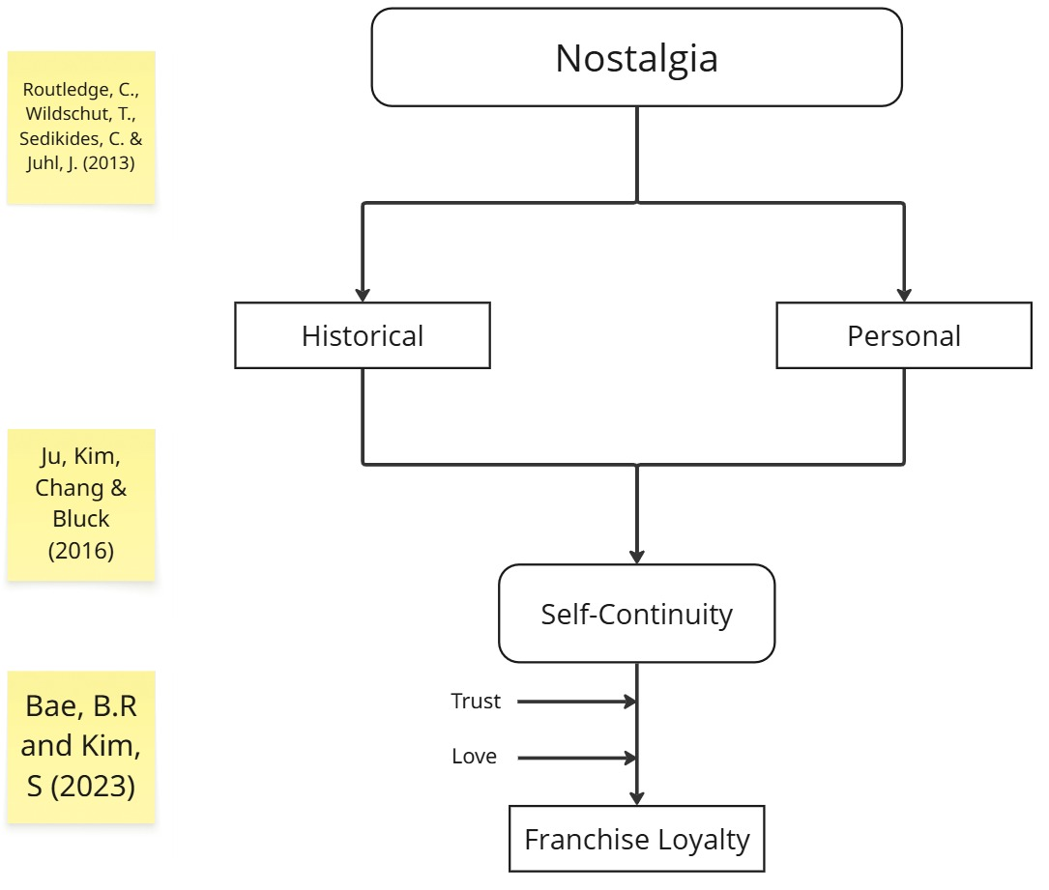
Figure 1: Old Conceptual Framework
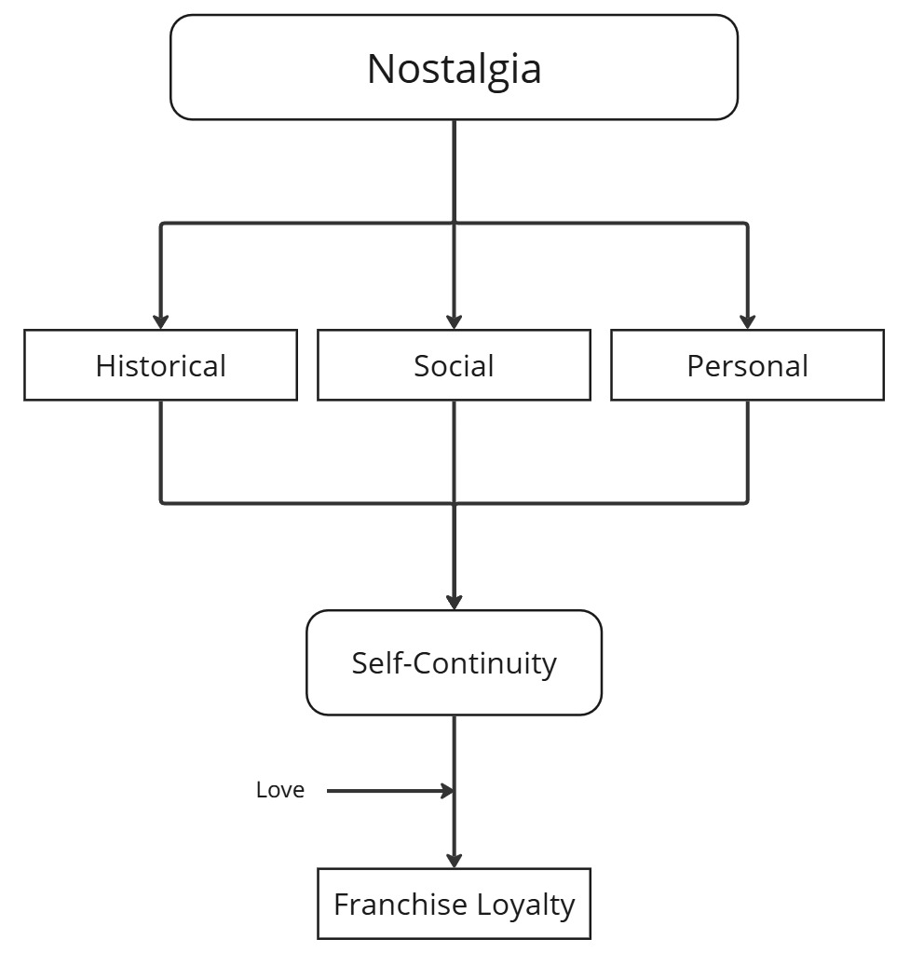
Figure 2: New Conceptual Framework
  - Quotes (Q)
P1 | - It feels like a little bit of a love letter maybe to to something of the past and that sort of by default connects me again back to different time back to growing up back to playing previous games and so yeah, of course there is. There is naturally a connection there.  - I'm still passionate about the franchise, but just perhaps not so much the the modern stuff, the consumer stuff.  - Always apprehensive. You know, I think the world has changed. We've moved on from those games and what those games gave us, so I'm always apprehensive. But I'm always keen to see I'm always keen to see and I'm always hopeful. Hopeful of quality in in in new games from them so.  - pulse of what's going on in with the games and new releases
P2 | - Yeah, just it's just a sense of childhood, remember? Like, times where you'd come back from after school and just grab your DS and play.
P3 | - I think I would resonate it more through others, although I do have personal ties with the game. They have been in the past and I think kind of seeing other people get excited gets me excited as well.  - Yeah, I think it is it it makes it's a little bit saddening seeing the sort of difference in gameplay and that nostalgia feeling not being present here, but it also adds that new feeling of excitement and anticipation for trying something like a little bit different.  - Although my trust has worried a bit. I would still be open to giving them the benefit of the doubt.  - I think I also remember how this almost expanded my my urge to play new games as well, which is a key part of my my, my personality, my interest. So yeah, I think yeah, it brought the nostalgia in, but it also reminds me of like. How far I've come since starting to play that game, you know?
P4 | - Used to be like top tier games that I feel like recently dropped in quality, although I haven't played the recent ones, but the old ones definitely held them to high standards.  - Yeah, I guess they in like with them acknowledging. The success I guess a bit older games are going back to that then, yeah, I guess so.  - So back then it meant a lot more I feel and everybody, all of our friends who had the same, played the same stuff.  - I mean, it's definitely a personal connection, but then obviously, since like I said earlier, like all my all my friends grown up, we're all into it. So I guess it's a bit of both.
P5 | - It was fun to see all the art styles and everything. I think in terms of bringing the Pokémon to life, it was really good at that. It was fun seeing the city like rendered.  - The last two games were 3D and the kind of janky. Can I see some non janky gameplay would be what I’m looking for.  - Rainbow 6 Siege was doing. Ubisoft was doing these scripted gameplay trailers at the time of like voice actors communicating like they were in a squad over the gameplay and I think those made you really excited for the game, even if the voice acting was really cheesy and over the top, it did, like, reflect what happened.
P6 | - I would say my broader experience of Pokémon and my broader connection with Pokémon is grounded and almost solely experienced through others, whether that be my two eldest siblings, yourself, friends from school, friends from wherever.  - there's something sort of about that transitionary tech between like the early and mid 2000s and like leading off from the console and like the game system base and design that was in the 90s and the 80s and like that sort of transition to the like the digital online platforms, massive multiplayer games and all of that there, it's really nostalgic.  - I think the music is one thing for sure. It's not so much leading up towards it, but as soon as you hear that iconic Pokémon track like as soon as you hear that you know what you're thinking… The music is emphatic. It builds through a landscape. It sells you a story, a dream. It unwraps a present in the video… I think the music really like tied together like it is very. It's trying to be evocative of something. It's stirring music, something that stood out to me  - even if it is a vocal harmony and I think that's like it's striking a human connection more than anything else.
P7 | - I probably connected to this one more than the other one on a real note, just because I'm a newer Pokémon player. So like because I'm not an obsessed fan, I connected to it more because I saw. Pokémon that I knew and that I liked.  - This one was probably more of a personal one because it connected me to me like my more recent getting into Pokémon like I've definitely gotten into it more through my boyfriend because he likes it. Like if I wasn't with him, I probably would not care as much as I do, but I like the fact that I care because I do think pokémon's cool.  - It annoyed me that it was a gameplay trailer, but it said it was not actual gameplay so it's fallen into the the modern art of game trailers.  - Me and my mum would play cooking Mama and gardening Mama on my DS when we waited for my dad to get ready.
P8 | - It did in the past so I’m sure they will get it right into the future at some point.
P9 | - The first Tomb Raider game for the first time ever again, and seeing that sort of 3D World, which was pretty amazing on PlayStation. And secondly on the PlayStation Doom One which you know the first time I played kind of head to head games not on a split screen.  - It would probably be understanding, understanding what it was that others would have enjoyed about it and sharing

  - Thematic Analysis (TA)
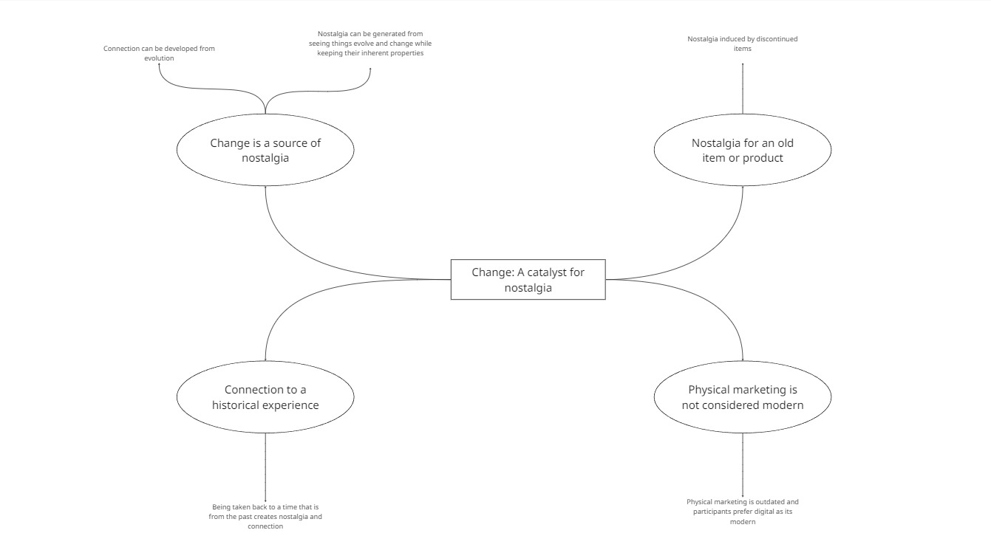
Figure 3: Change: A Catalyst for nostalgia
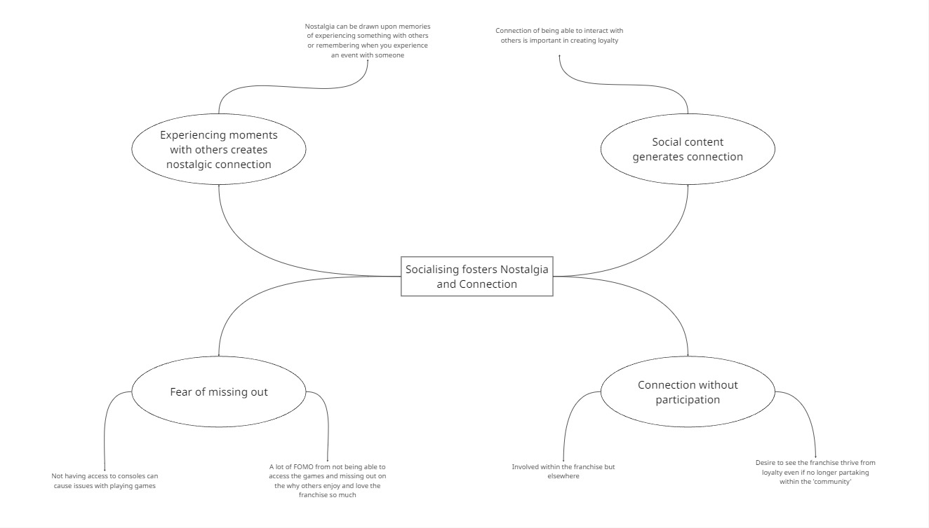
Figure 4: Socialising fosters nostalgia and connection
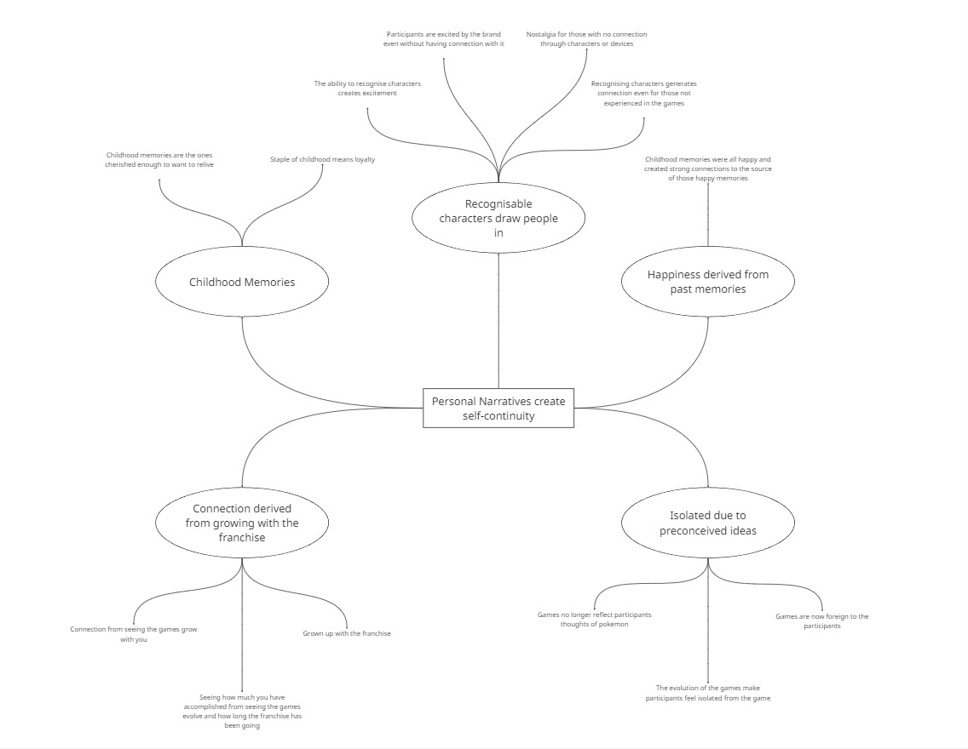
Figure 5: Personal narratives create self-continuity
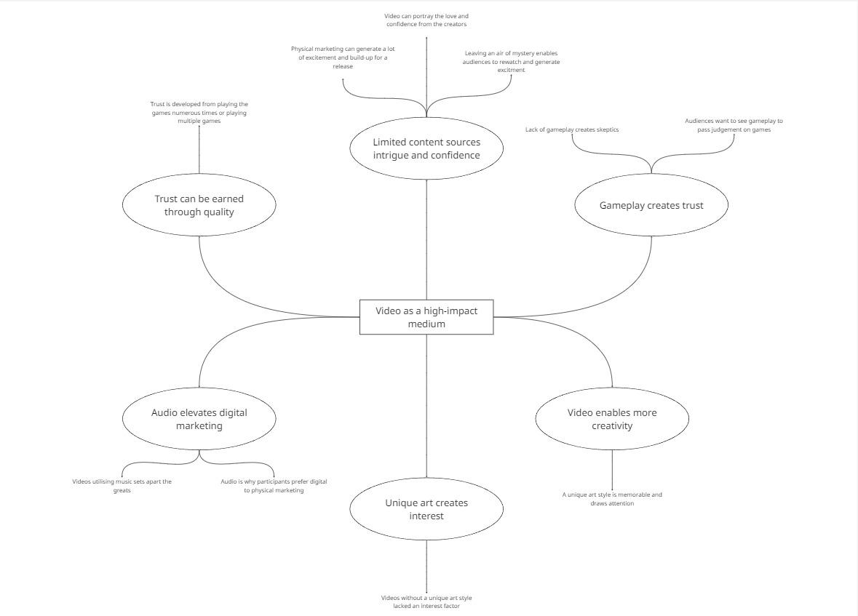
Figure 6: Video as a high-impact medium

